WILCANNIA FIELD & FUN DAY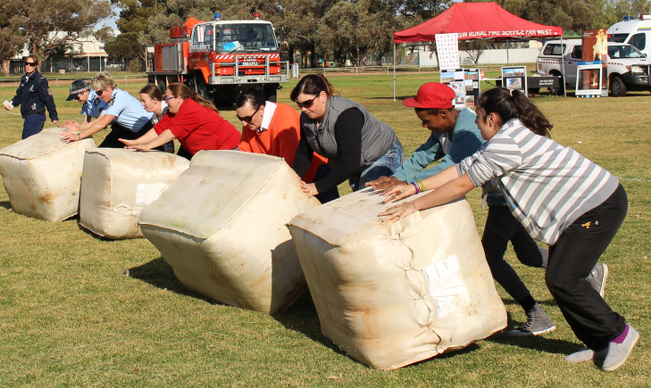
Celebrating the 150th Anniversary of the Gazettal of Wilcannia as a Town
Activities and Events
Saturday, 11 June 2016 History of Wilcannia display and gathering at Golf Club Meeting Room
Supper Dance -Dress code: Smart Casual

Sunday, 12 June 2016 Burke Park 10am – 4 pm

Welcome and Opening
Sheep Shearing Demonstrations
Sheep Dog Demonstrations

Wilcannia Gift Foot Race 1 km - Boys & Girls sections. Children between 5 & 12 years
First Prize $50 Cash, Second Prize $30 Cash, Third Prize $20 Cash plus Trophies

Wilcannia Gift Foot Race 3 km - Adults Men’s
First Prize: $150, Second Prize: $75, Third Prize: $50

Wilcannia Gift Foot Race 3 km - Adults Women’s
First Prize: $150, Second Prize: $75, Third Prize: $50

Wool Bale Rolling – Men’s, Women’s and Mixed Events : (2 persons Team)
First Prize: $100, Second Prize: $60, Third Prize: $40 - Prizes for each group

Tug-of-War : Juniors: Boondies
Winning Team - $10 per child. Participating Team - $5 per child

Tug-of-War : Seniors: Boomerangs and Parntu Warriors
Winning team - $300

Photo Competition: 3 categories – People, Landscapes, Animals.

Each category, 1st Prize: $50; 2nd Prize $30; 3rd Prize: $20.
Peoples’ Choice - $50 (1)
Attractions: Trade Displays, Baking Competition, Horses, Rural Fire Services Fire Demo, Jumping Castle and Slide.
Golf Club Restaurant opens from 5.30 pm. A La Carte Menu

