WILCANNIA FIELD & FUN DAY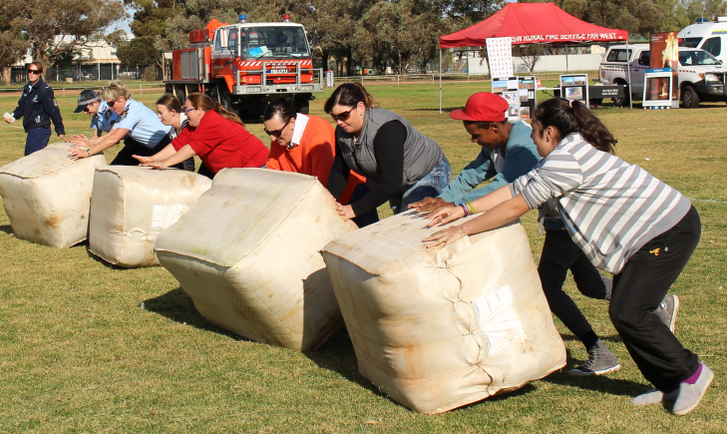
Celebrating the 150th Anniversary of the Gazettal of Wilcannia as a Town
Activities and Events
Saturday, 11 June 2016 History of Wilcannia display and gathering at the Hall – please bring an item to share if possible
Supper Dance at Golf Club-Dress code: Smart Casual

Sunday, 12 June 2016 Burke Park 10am – 4 pm

Welcome and Opening
Sheep Shearing Demonstrations, Compliments Mick Williams, Donated by “Netallie Stn”
Sheep Dog Demonstrations. Sponsored by G.N. Proud and Co. Donated by Moira Plains Stn..

Wilcannia Gift Foot Race 1 km - Boys & Girls sections. Children between 5 & 12 years
First Prize $50 Cash, Second Prize $30 Cash, Third Prize $20 Cash plus Trophies

Wilcannia Gift Foot Race 3 km Men’s over 12. Sponsered by Rick and Jo Gates. $150-
2nd. Prize, $75-. Sponsored by Third Prize: $50

Wilcannia Gift Foot Race 3 km -Women’s over 12. Sponsered by The Crisp Family
First Prize: $150, Second Prize: $75, Third Prize: $50

Wool Bale Rolling – Men’s, Women’s and Mixed Events : (2 persons Team)
First Prize: $100, Second Prize: $60, Third Prize: $40 - Prizes for each group

Tug-of-War : Juniors: Boondies
Winning Team - $10 per child. Participating Team - $5 per child

Tug-of-War : Seniors: Boomerangs and Parntu Warriors
Winning team - $300

Photo Competition: 3 categories – People, Landscapes, Animals.

Each category, 1st Prize: $50; 2nd Prize $30; 3rd Prize: $20.
Peoples’ Choice - $50 (1)
Attractions: Trade Displays, Baking Competition, Horses, Rural Fire Services Fire Demo, Jumping Castle and Slide.
Golf Club Restaurant opens from 5.30 pm. A La Carte Menu

